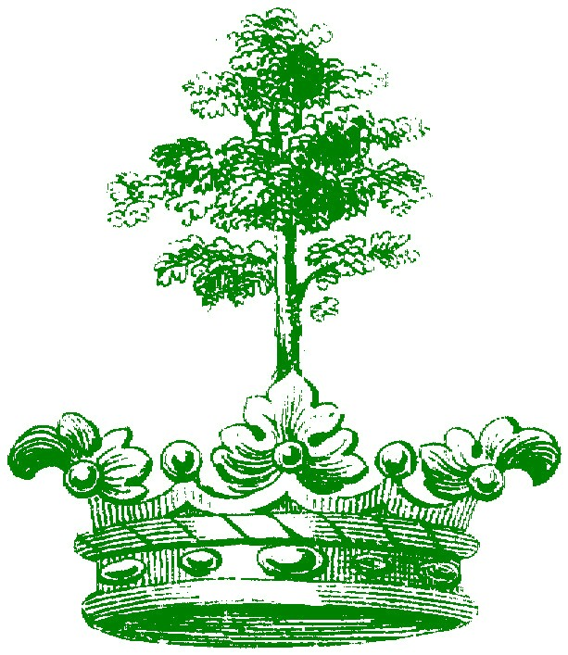
Miss Circle City Forestry

A Preliminary Pageant
To the Alabama Forestry Scholarship Program

March 9,2008

Day: SUNDAY

Place: Doug Tew Center

Dothan, Alabama
Interviews Begin at 12:15 p.m. Pageant starts at 3:30 p.m.

Be a part of the winning system!
VISIT OUR WEBSITE FOR MORE INFO, http://ccforestry.tripod.com/

Every contestant receives gifts – no one goes home empty handed!
This is an open pageant. Everyone may compete.

Divisions:
Miss Circle City (17-23) – Suit/Long pageant gown
Teen Miss Circle City (14-16) – Suit/Long Pageant gown
Junior Miss Circle City (11-13) – Long pageant gown
Petite Miss Circle City (9-10) – Long pageant gown
Little Miss Circle City (6-8) – Heirloom or Pageant
Tiny Miss Circle City (4-5) – Heirloom or pageant
Teeny Miss Circle City (2-3) – Heirloom, Sunday or Pageant
Baby Miss Circle City (0-23 months) – Heirloom, Sunday or Pageant

Applications will be accepted until March 6, 2008.
Score sheets will be available at the pageant for $5.00.
E-mail us at:
Circlecityforestry@yahoo.com
Goodsongirl@aol.com
My4sweetangels@aol.com

Contact:
Kim White and Sandy Goodson
(334)237-1401
(334) 791-7095
Home (334) 794-1135

**Baby thru Junior Divisions**

Attire is listed above for each age group.
Make-up can be worn, but use moderation and keep child age-appropriate.

Contestants will compete in Photogenic (5%), Beauty (20%), Stage Presence (35%), Poise/Personality (30%), On-stage question (10%) “Baby & Teeny will not have on stage question!”

Photogenic pictures DO NOT have to be professional.

Score sheets will be made available for purchase.

Optional interview: Interview times will be given out after the deadline! Attire should be Church/Sunday attire or age-appropriate suit.

Scores are NOT calculated with final pageant score and all score sheets for optional interview will be returned at end of pageant.

**Teen and Miss**

Teen Miss and Miss – Interview times will be given out after the deadline

Attire should be (1) Interview Suit – for panel interview with judges. (2) Evening Gown for stage competition.
Contestants will compete in Photogenic (5%), Panel interview (40%), Beauty (25%), Poise/Stage Presence (20%), On-stage question (10%).
Portfolio – One (1) master copy typed and attached with a paperclip (no staples). Three (3) copies with cover sheet, and bio page. Please place in clear binder with one (1) photogenic picture. Must be turned in prior to interview. These books will be turned into the judges for interview. Teen and Miss will have 5 minute interview.

Fees:
Baby Miss through Junior Miss & Ms - $75.00 – Beauty, On-stage Question, Photogenic
Teen Miss – Miss – $75.00 – Interview, Beauty, On-stage Questions, Photogenic

Optionals:
Interview $10.00 – (except Teen & Miss)

If you are going to enter at the door YOU must email the director or call first!
Every contestant receives gifts – no one goes home empty handed!

Rules:

- All contestants and queens may be photographed and posted to website. Circle City Forestry has the right to use pictures taken during pageant or at any events.
- Contestants cannot be married, have been married, pregnant or have a child.
- Contestants will receive fees paid to state pageant. All other fees (ads, etc.) are the responsibility of the contestant/parent.
- Queens must be on time and dressed appropriately at all functions.
- Notify director if not able to attend events as planned. All events are posted to http://ccforestry.tripod.com/ website and it is the responsibility of the contestant/parent to check calendar.
- A smile is mandatory attire at all events.
- Queens cannot smoke, drink and must conduct themselves in a respectful manner at all times.
- Prizes: Crown, Monogrammed Banner, Crown Case, Monogrammed parade blanket, and more.
- Miss Circle City Forestry Queens must compete at the Alabama Forestry State Pageant or must relinquish her title/crown/gifts.
- All queens may continue to compete in other pageants. There are NO contractual obligations to Miss Circle City Forestry. In the event, Miss Circle City Forestry is crowned Miss Alabama Forestry, all titles must be relinquished to fulfill obligation to Miss Alabama Forestry.

-----------------------------------------------------------------------------------------------
I, , give permission for my child, , to be in the Miss Circle City Forestry Pageant, an Alabama Forestry preliminary pageant. I understand that the pageant committee and __________________ are not responsible for any losses or injuries. I agree to abide by all rules listed above and to accept the judge’s decision as final. I, in return, expect to see my scores at a later date following the pageant. If I am chosen a winner, I promise to make every possible effort to attend functions, and etc. as my director deems important.

Contestants Signature Date
Parents Signature Date

Return to:

Kim White and Sandy Goodson

Miss Circle City Forestry
225 Goody Lane
Midland City, Alabama 36301
cell (334)237-1401
(334)791-7095

Miss Circle City Forestry
Entry Form (Please type)

Name: Division:

Address: City: Zip:

Home Phone: 2nd Phone:

Age: Date of Birth: Grade:

E-Mail address:
School:

Parents:

Brothers/Sisters:

Special Interests/Hobbies/Organizations:

Favorite Charity:

How would you promote the Forestry Industry:

Please feel free to call us with any questions. We will be more than happy to help you any way we can. The more contestants we get, the bigger and better the prizes will be. Don’t miss out on all the fun. We can’t wait to meet all the contestants and we look forward to seeing you all there!!!

Admission:

$5.00 for individual pageant passes
Forestry Queens ONLY will receive free pass.
(5 and under free)

